Kathmandu University
Department of Computer Science and Engineering
Dhulikhel, Kavre


COMP 307
Lab Report
on
“Introduction to Linux”

Submitted by
Jatin Madhikarmi (32)

Submitted to
Ms. Rabina Shrestha
Department of Computer Science and Engineering

Submission Date: December 10 , 2025

Table of Contents
1)What is Linux 5
2)The Linux Hierarchical File System. 5
3)Importance of Linux commands in Operating Systems. 6
Directory and File Navigation 8
1. pwd (Print Working Directory) 8
2. ls (List) 8
3. ls -a (List All) 8
4. ls -l (Long Listing Format) 9
5. cd (Change Directory) 11
File and Directory Manipulation 11
6. mkdir (Make Directory) 11
7. rmdir (Remove Directory) 12
8. rm (Remove) 12
10. touch 14
11. cat (Concatenate) 14
12. nano, vi, jed 14
13. cp (Copy) 18
14. mv (Move) 18
Searching and System Information 19
15. locate 19
16. echo 19
17. uname -a (Unix Name - All) 20
18. df -h (Disk Free - Human-readable) 20
Process Management and Permissions 21
19. ps -u $USER (Process Status - for User) 21
20. top 22
21. chmod (Change Mode) 22

List of Figures
Figure 1: pwd command 7
Figure 2:ls command 7
Figure 3:ls-a command 8
Figure 4:ls-l command 9
Figure 5: cd command 10
Figure 6.1: mkdir command 10
Figure 6.2: checking mkdir command 11
Figure 6.3: Result of the above command 11
Figure 7.1: rmdir command 11
Figure 7.2: Checking rmdir command 11
Figure 7.3: Result of the above command 11
Figure 8: rm command 12
Figure 9:rm-r command 12
Figure 10:touch command 13
Figure 11: cat command 13
Figure 12.1: nano command 14
Figure 12.2: nano terminal 14
Figure 12.3: jed command 14
Figure 12.4: jed terminal 15
Figure 12.5: vi command 15
Figure 12.6: vi terminal 16
Figure 13: cp command 17
Figure 14.1:mv command for move 17
Figure 14.2: mv command for rename 18
Figure 15: locate command 18
Figure 16: echo command 18
Figure 17: uname -a command 19
Figure 18: df-h command 19
Figure 19.1: ps -u $USER command(General User) 20
Figure 19.2: ps -u $CHRONOS command(Specific User) 21
Figure 20: top command 21
Figure 21: chmod command 22

1)What is Linux
Linux is a family of open-source Unix-like operating systems based on the Linux kernel. It is one of the most prominent examples of free and open-source software collaboration.
- Operating System (OS): Linux is the software on a computer that enables applications and users to access the devices on the computer to perform desired functions. The OS is responsible for managing hardware resources, such as the CPU, memory, and disk storage.
- Kernel: The Linux kernel is the core component of the operating system. It acts as the main interface between the computer's hardware and its processes.
- Open Source: This means the source code for the OS is freely available to anyone. Users can run, study, modify, and redistribute the code.
- Distribution (Distro): A Linux distribution is a complete operating system built on the Linux kernel. It includes the kernel, system utilities, a package management system, a collection of applications, and sometimes a graphical desktop environment. Popular distributions include Ubuntu, Fedora, Debian, Mint, and Red Hat Enterprise Linux.

2)The Linux Hierarchical File System.
The Linux file system is organized in a hierarchical structure, resembling an inverted tree, with a single root directory denoted by a forward slash (**/$) at the very top. All files and directories are organized under this root. This standard is defined by the Filesystem Hierarchy Standard (FHS).
Directory | Purpose
/ (Root) | The primary hierarchy root of the entire file system.
/bin | Binaries (Essential user command executables, like ls and cat).
/sbin | System Binaries (Essential system administration executables).
/etc | Etc. (Host-specific configuration files).
/home | User home directories (e.g., /home/user1).
/usr | Unix System Resources (Secondary hierarchy for user-related programs and data; contains most user utilities and applications).
/var | Variable files (Files whose content changes often, like logs and mail queues).
/dev | Devices (Contains device files for hardware like hard drives, CD-ROMs, and terminals).
/proc | Processes (Virtual filesystem providing process and system information).
/tmp | Temporary files (Files that are created and deleted constantly).
/opt | Optional add-on application software packages.

3)Importance of Linux commands in Operating Systems.
Linux commands, executed primarily in the Terminal (or Command Line Interface/CLI), are critically important for the following reasons:
- Automation and Scripting: Commands can be combined into scripts (e.g., Shell scripts) to automate repetitive and complex tasks (backups, deployments, system maintenance) efficiently and reliably.
- Precision and Power: The CLI provides fine-grained control over the system, allowing users to perform complex administrative tasks, networking operations, and file manipulation with precision that is often not available or much slower in a Graphical User Interface (GUI).
- Resource Efficiency: The CLI uses significantly fewer system resources (CPU, RAM, and graphical rendering) compared to a GUI. This is crucial for servers, embedded systems, and resource-constrained environments where Linux is dominant.
- Remote Administration: System administrators typically manage Linux servers remotely via protocols like SSH. Since these servers often run without a GUI, mastery of command-line tools is essential for maintenance, troubleshooting, and configuration.
- Standardization: Unix-like systems share a common set of foundational commands, making skills transferable across different distributions and even other operating systems (like macOS).

Linux Commands

Directory and File Navigation

pwd (Print Working Directory)
The pwd command stands for "Print Working Directory." Its primary purpose is to display the complete, absolute path name of your current location within the Linux file system hierarchy. This is crucial for navigating and understanding your position relative to the root directory (/). If you are executing scripts or referencing files, knowing the output of pwd is essential for specifying correct relative or absolute paths.
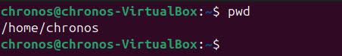

Figure 1: pwd command

ls (List)
The ls command is one of the most fundamental tools, used to list the files and subdirectories contained within a directory. When executed without any arguments, it shows the contents of the current working directory. The command is a quick way to inspect a directory, and by default, it sorts the output alphabetically for easy reading.
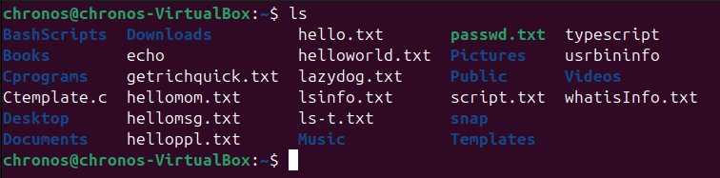

Figure 2:ls command

ls -a (List All)
The -a option modifies the standard ls command to list all files and directories, which is critical for system administration and configuration. This is necessary because, by convention, many system and user configuration files are "hidden" by starting their names with a dot (e.g., .bashrc, .ssh). Using ls -a ensures you can see and manage these important hidden items alongside regular files.
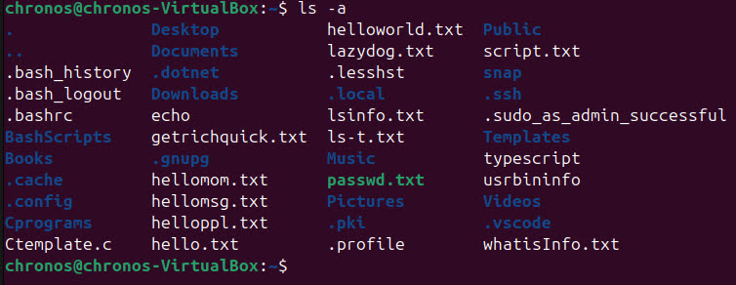

Figure 3:ls-a command

ls -l (Long Listing Format)
The -l option provides a comprehensive, long listing format of a directory's contents, displaying crucial metadata about each file or directory. This output includes detailed information such as the file permissions (read, write, execute), the number of hard links, the file owner and group, the exact file size in bytes, and the date and time of the last modification. This level of detail is invaluable for managing permissions and troubleshooting access issues.

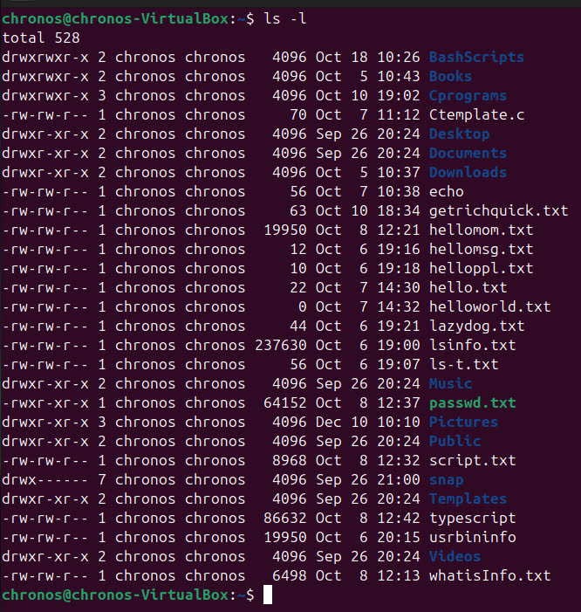Figure 4:ls-l command

cd (Change Directory)
The cd command is used to change your current working directory and is the primary tool for navigating the file system. You can move to any directory by specifying its path, whether it's an absolute path starting from the root (/) or a relative path from your current location. Simple shortcuts like cd .. move you up one level (to the parent directory), and cd ~ will quickly take you back to your home directory.
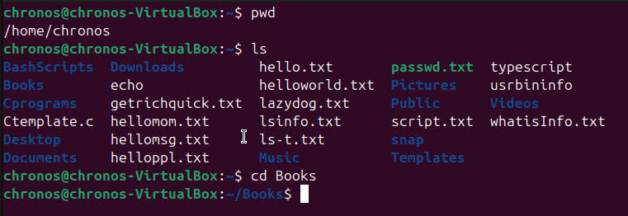

Figure 5: cd command

File and Directory Manipulation

mkdir (Make Directory)
The mkdir command is used to create a new directory (or folder) at a specified location. You simply provide the desired name for the new directory as an argument to the command. It is essential for organizing files and creating structured projects within the Linux file system.

Figure 6.1: mkdir command

Figure 6.2: checking mkdir command
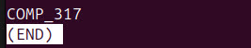

Figure 6.3: Result of the above command

rmdir (Remove Directory)
The rmdir command is designed to delete an existing directory from the file system. A crucial limitation of this command is that it only works on empty directories; if the specified directory contains any files or subdirectories, the command will fail and produce an error message. For removing non-empty directories, you must use the more powerful rm -r command instead.

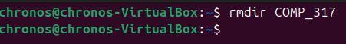

Figure 7.1: rmdir command

Figure 7.2: Checking rmdir command


Figure 7.3: Result of the above command

rm (Remove)
The rm command is used to permanently delete files from the file system. It is a powerful tool,as, unlike deleting in a graphical interface, files removed with rm are typically not recoverable from a trash bin. Users should exercise caution when using rm, especially with wildcards, as the deletion is immediate and permanent.
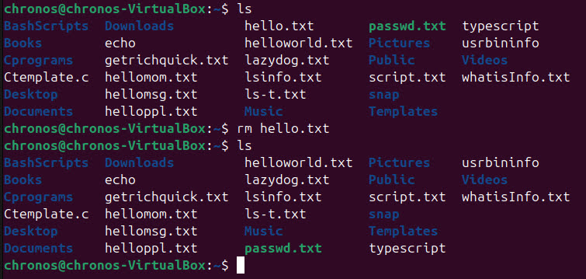

Figure 8: rm command

rm -r (Remove Recursively)
The -r (recursive) option modifies the rm command to handle directories and their entire contents. This is the command necessary to delete non-empty directories as it first deletes all files and subdirectories inside the target directory and then deletes the directory itself. Due to its destructive nature, this combination is the most dangerous command for deleting files and must be used with extreme care.
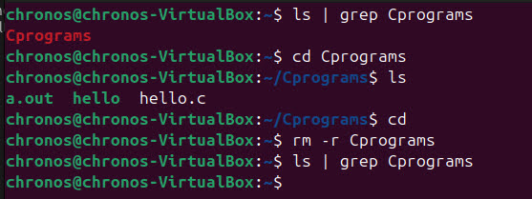

Figure 9:rm-r command

touch
The touch command serves a dual purpose regarding file timestamps and creation. Its primary use is to create a new, empty file when one does not already exist. However, if a file does exist, touch updates the file's access and modification timestamps to the current time without altering the file's contents.
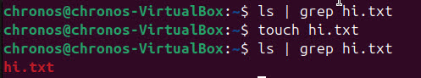

Figure 10:touch command

cat (Concatenate)
The cat command, short for "concatenate," is most often used to quickly display the contents of one or more files directly to the terminal screen. While it can join multiple files into a single output stream, its daily use is primarily for viewing the content of small text files. It is a simple and immediate way to inspect file content without needing to open a text editor.
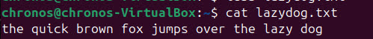

Figure 11: cat command

nano, vi, jed
These names represent various text editors that operate directly within the command-line interface, making them essential tools for configuring Linux systems and writing scripts. vi (and its modern version, vim) is a classic, highly powerful, but complex modal editor found on virtually all Unix-like systems. nano is favored by beginners for its simpler interface and on-screen help menu, while jed is another common editor known for its Emacs-like key bindings.

Figure 12.1: nano command
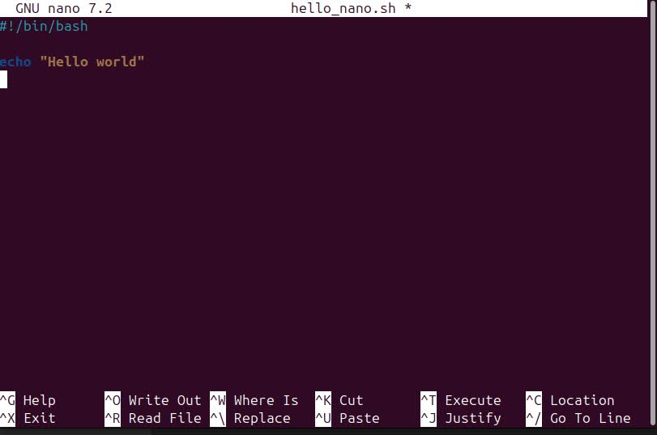

Figure 12.2: nano terminal

Figure 12.3: jed command

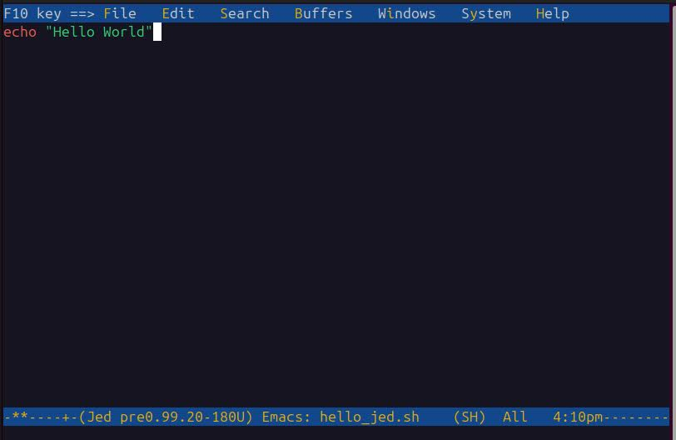

Figure 12.4: jed terminal
Figure 12.5: vi command
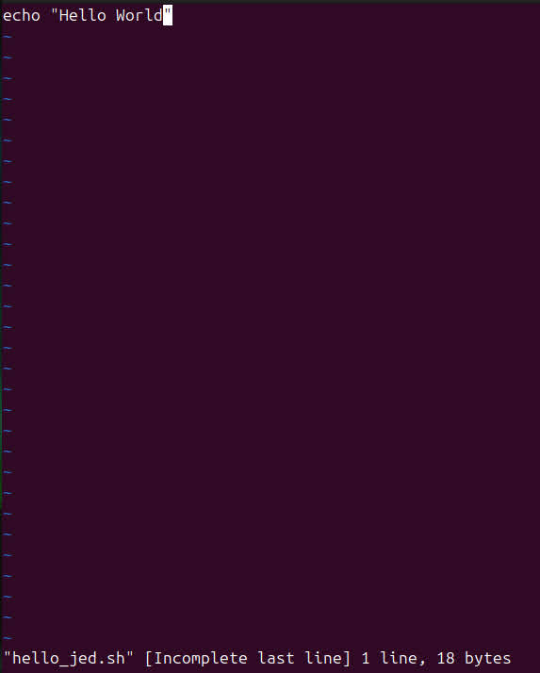

Figure 12.6: vi terminal

cp (Copy)
The cp command is used to copy files and directories from a source location to a destination location. You must specify the original file (source) and the name and location of the new copy (destination). To copy directories and their contents, you must include the recursive option (-r), much like with the rm command.
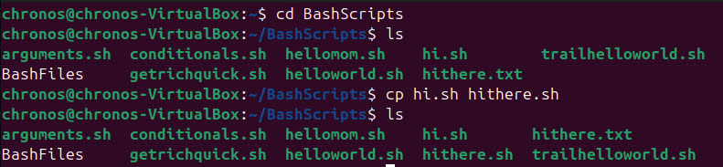

Figure 13: cp command

mv (Move)
The mv command is a versatile utility used for two distinct but related operations: moving files or directories to a different location, or renaming them. To rename an item, you simply use mv to "move" the file to the same directory but with a new name. Unlike copying, the original file is deleted after the operation is complete.
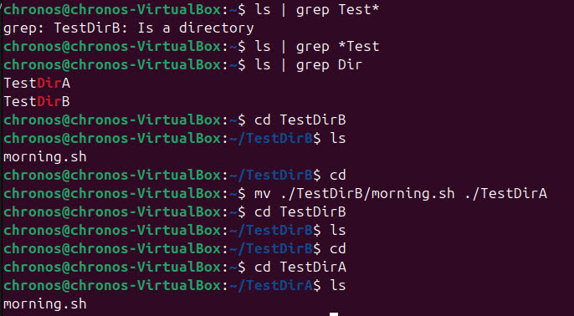Figure 14.1:mv command for move
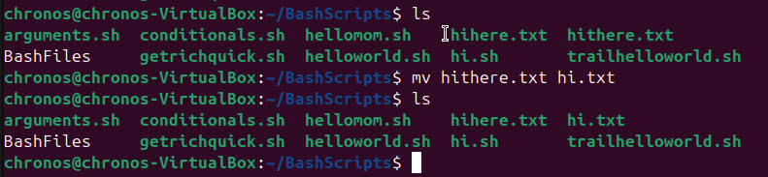

Figure 14.2: mv command for rename

Searching and System Information

locate
The locate command is a highly efficient tool used to search for files by name across the entire file system. It achieves its speed by querying a pre-built and regularly updated database of all file names, rather than searching the file system in real-time. Because of this reliance on a database, it is extremely fast but can only find files that existed when the database was last updated.

Figure 15: locate command

echo
The echo command is primarily used to display a line of text or a string to the standard output, which is usually the terminal. It is a fundamental tool used extensively within shell scripts to output messages to the user, insert text into files, or display the current values of environment variables.

Figure 16: echo command

uname -a (Unix Name - All)
Function: The uname -a command provides a comprehensive summary of the operating system's kernel and hardware information. The -a flag stands for "all" and outputs details such as the kernel name (e.g., Linux), the hostname of the system, the kernel release version number, the specific version build, and the machine's hardware architecture. This output is essential for determining compatibility or reporting system details for debugging purposes.

Figure 17: uname -a command

df -h (Disk Free - Human-readable)
The df command reports the amount of free and used disk space on all mounted filesystems. The -h option is critical because it tells the command to output the sizes in a human-readable format, using appropriate units like megabytes (M) or gigabytes (G) instead of raw bytes. System administrators use this command constantly to monitor storage capacity and ensure drives do not fill up unexpectedly.
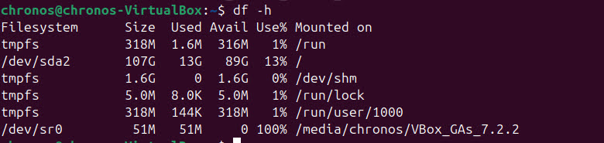

Figure 18: df-h command

Process Management and Permissions

ps -u $USER (Process Status - for User)
The ps command is used to display information about currently running processes. The -u $USER option filters this list specifically to show only the processes owned by the user currently executing the command (indicated by the $USER variable). This provides a quick way to monitor the resource usage and status of your personal applications and background tasks.
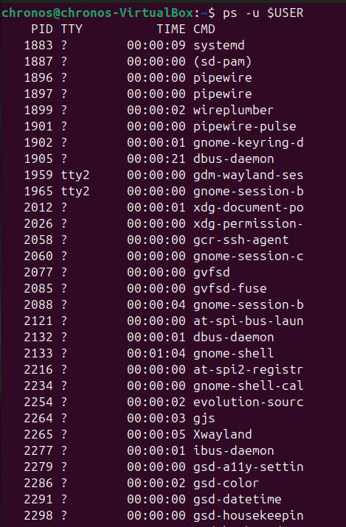
Figure 19.1: ps -u $USER command(General User)

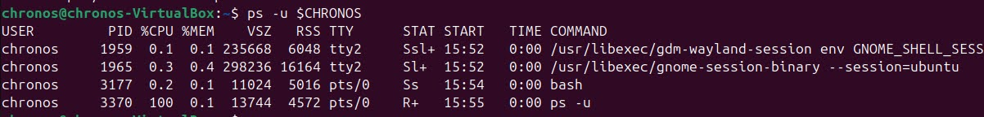

Figure 19.2: ps -u $CHRONOS command(Specific User)

top
The top command provides a dynamic, real-time view of the running system and process activities, making it an essential monitoring tool. It continuously updates the display to show critical system metrics like CPU usage, memory consumption, and swap space. Below the summary, it lists individual processes, ordered by CPU usage, allowing administrators to quickly identify resource-intensive applications.

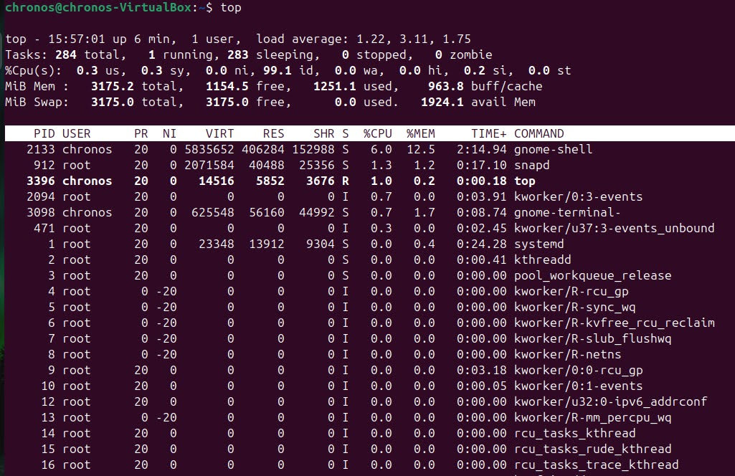Figure 20: top command

chmod (Change Mode)
The chmod command is used to change the access permissions of a file or directory. These permissions define who can read (r), write (w), or execute (x) a file, categorized by the file's owner (u), the group (g), and others (o). Permissions are typically set using a three-digit octal number (like 755), where each digit represents the permissions for one category.
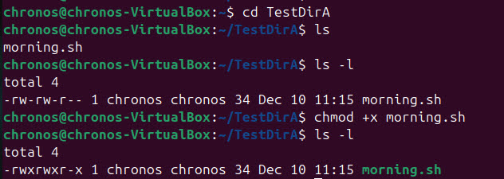

Figure 21: chmod command

